**Electricity generation**

National grid website provides a breakdown for the energy sources.

We have become a throwaway society

The UK government imports electricity. The UK has reduced emissions but it has exported the problem. For example, coal power stations in the UK are no more. However, the energy that is being imported from countries like France is being generated by their coal power stations.

**Types of energy sources:**

Photo-voltaic - solar

Coal (no longer used)

Oil

Biomass

Wind

Wave

Hydro

Nuclear

Coal and oil is used to burn water. Or heat water into steam. The stream is used to turn a generator to create power. When you have movement you can turn it into electricity somehow.

Nuclear - works the same as coal and oil power stations. Nuclear has virtually zero emissions. However, it does produce waste.

**Electricity Supply.**

Once electricity is generated, you put it into a step -up transformer

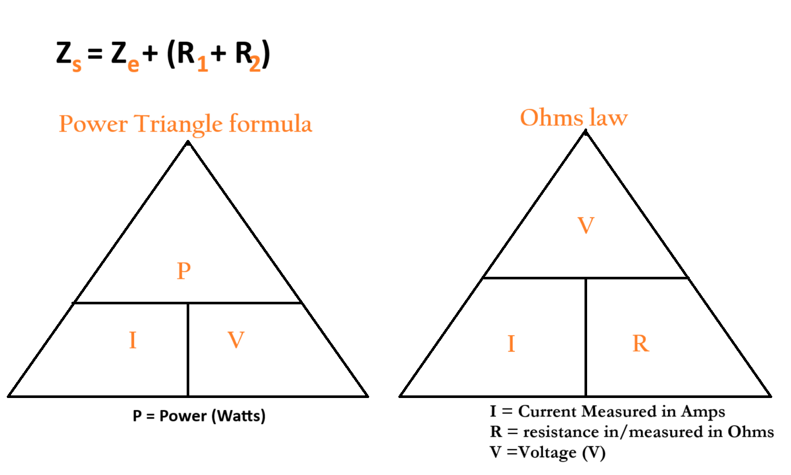

**Voltage** - pushes electrons. It is the pushing force.

**Current** - warms up the cable. If you reduce the current but increase the voltage you can have smaller cables.

**Transmission Voltage:**

* 400 Kv – 275Kv — 132kv

**Three distribution voltages** are used:

* 33 Kv
* 11 Kv
* 400/230 Kv

Phone chargers step-down the voltage of electricity from **230V** to **5V**

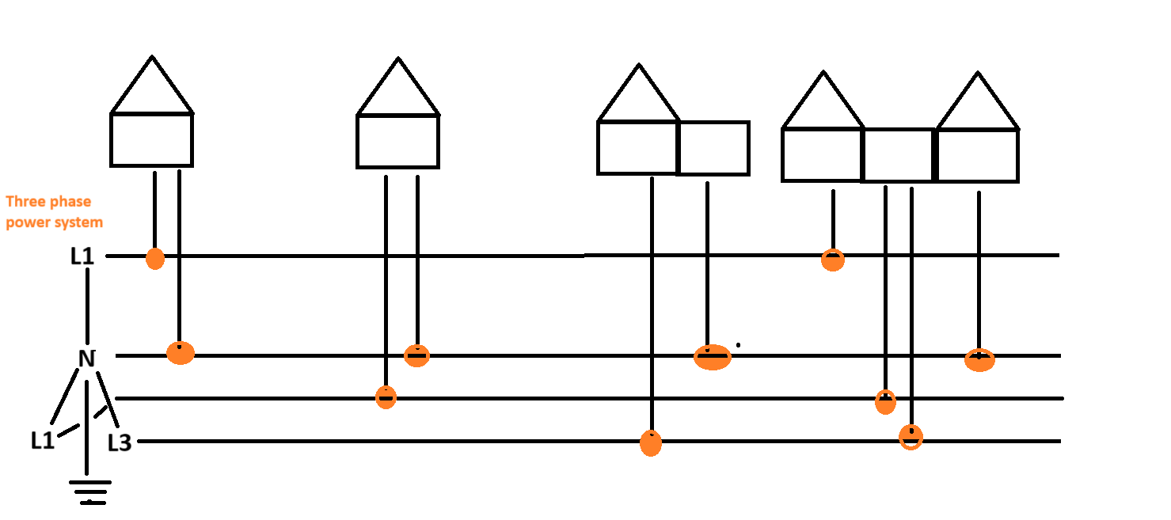

**Earthing System**

Two conductors Live and Neutral plus earth enter the home premise.

**Washing machine**

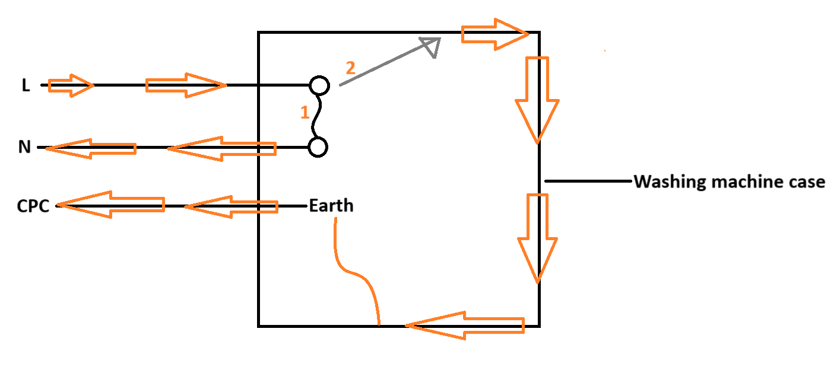

**In a Socket plug**

The earth pin in the socket plug is the longest. This means that it is the first to connect and last to disconnect. This is a safety mechanism.

TN-S = Terra Neutral separated

TN-C-S = Terra Neutral Combined Separate

TT = Tera Tera

TN-C-S = the amount of current between the point A and Point B and back to point A is 0.35.

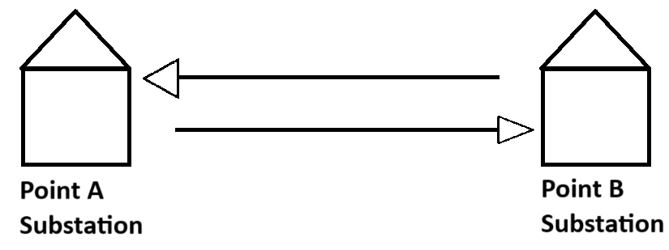

Earth loop impedance

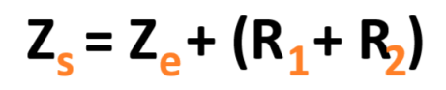

BSEN-61009-RCBO

B32



What is the difference between Power and Volts?

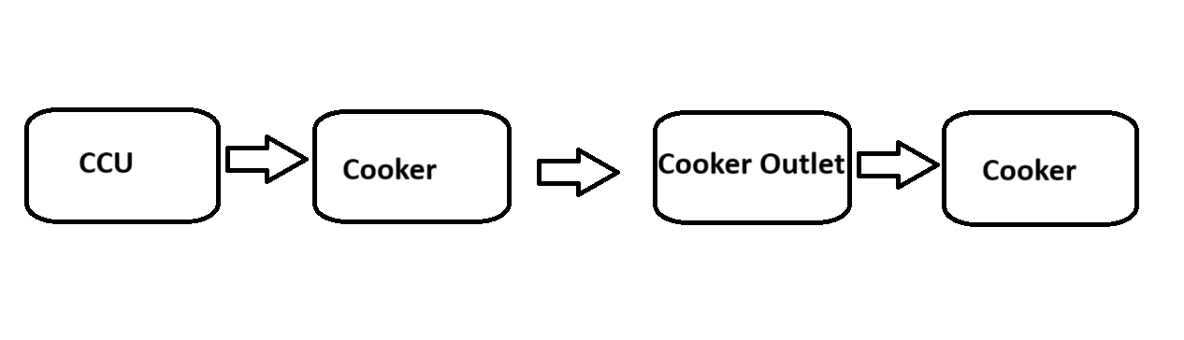

**Question:**

Calculate the assumed demand for a **230 volt** cooker which contains:

* 2 x 1.0 w Hob plates
* 2 x 2.0 Kw hob plates
* 1 x 2.0 Kw oven/grill
* 1 x 3.0 Kw oven

**Working out:**

**Step one:**

Perform a multiplication on all the above bullet points.

2 x 1.0 kW Hob plates = **2.0 kW**

2 x 2.0 kW Hob plates = **4.0 kW**

1 x 2.0 kW Hob plates = **2.0 kW**

1 x 3.0 kW Hob plates = **3.0 kW**

**2.0 kW + 4.0 kW + 2.0 kW + 3.0 kW = 11kW**

**11 kW is the full load. Load means how much electrical power is required for it to work.**

**Step two:**

* We want the Current.
* Current is represented as I in the PIV diagram below.
* Therefore, the calculation for is current is:
* current => Power / Volts.

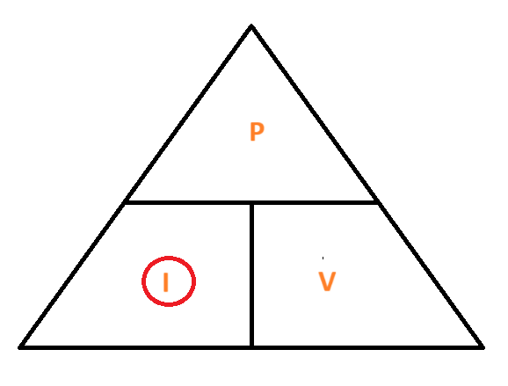

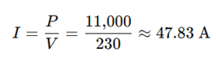

11,000 / 230 volts = 47.83 amps

**Step 3 - Check the diversity rules.**

* When we calculate the current of an appliance, there is an additional step that may need to be followed;
* For calculations that involve current you may need to apply a **diversity rule**. To know whether you need to compute the latter or not check if the appliance appears on **Table A1** on **page 136**;
* If yes, apply diversity calculation. In this instance a cooker does appear on **Table A1** on **page 136**.

On the **Table A1 page 136** this extract is applicable to us:

**Simplified version - to check for diversity rules**

1. 47.83 - **10A** = 37.83
2. 37.83 x 0.3 = **11.35**
3. **10 A** + **11.35** = 21.35
4. 21.35 + **5 A** = 26.35 A

**Full version - to check for diversity rules**

“Household cooking appliance”

“The first 10 A of the rated current plus 30% of the remainder of the rated current plus 5 A if a socket-outlet is incorporated in the control unit”

**Part one**

“The **first** 10 A of that rated current”

(47.83 amps - 10 amps)

10 amps

**Part two**

“Plus 30% of the **remainder** of the rated current”

**Remainder =>** 47.83 amps - 10 amps = **37.83 amps**

**Remainder => 37.83 amps**

30% of the remainder

37.83 A x 0.3 = 11.349

11.349 round up to 2 decimal places = **11.35**

**Part three**

The first 10 A of the rated current plus 30% of the remainder of the rated current

Therefore, 10 amps + 11.35 amps = 21.35 amps

**Part four**

“Plus 5 A if a socket-outlet is incorporated in the control unit”

21.35 + 5 Amps = **26.35 amps**